**Views in ASP.NET Core MVC**

**View in MVC**

* Contains the logic to display the Model data provided to it by the Controller.
* A view is an HTML template with embedded Razor markup.
* A view file has .cshtml extension if the programming language is C#.

**Where are View files stored**

* By default, MVC looks for view files in the **Views**folder
* View files that belong to a specific controller are stored in a sub-folder in the **Views** folder and that sub-folder has the **same name as the controller.**
* The view file has the **same name as that of the controller action method**with a **.cshtml**extension

**Example**   
  
For example, let's say, in our MVC project we have 2 controllers - HomeController and EmployeesController   
  
HomeController has the following 3 action methods.

* Index()
* Details()
* Edit()

EmployeesController has the following 3 action methods.

* List()
* Details()
* Edit()

**Views Folder Structure**   
  
The following diagram demonstrates **views folder structure**   
  
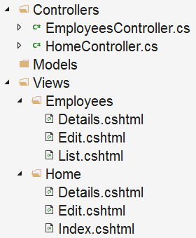

* For each **Controller**we have a separate folder in the **"Views"** folder.
* All the **HomeController**views are in **Home**folder in the **"Views"** folder.
* All the **EmployeesController** views are in **Employees**folder in the **"Views"**folder.
* Each view file has the **same name**as the **controller action method**.

**Views Discovery**   
  
Consider the following HomeController. We have only one action method - Details(). The Details() action returns a View using the View() method. This View() method is provided by the Controller base class.

public class HomeController : Controller  
{  
    public ViewResult Details()  
    {  
        return View();  
    }  
}

Since we are returning a **View**from the action method that is named **Details()**, by default MVC looks for a view file with same name that has .cshtml extension. So in this case, it looks for **Details.cshtml**. It looks for this file in the following 3 locations in the order specified

* First in "/Views/Home/" folder beacause the Controller name is HomeController
* Then in "/Views/Shared/" folder
* Finally in "/Pages/Shared/" folder

If a view file is found, the HTML generated by the view is sent back to the client who made the request. If the view file is not found we get the following error.   
  
InvalidOperationException: The view 'Details' was not found. The following locations were searched:  
/Views/Home/Details.cshtml  
/Views/Shared/Details.cshtml  
/Pages/Shared/Details.cshtml